**PART - A**

**Expt 1: Generate and detect BASK (Binary Amplitude Shift Keying) Signal using Communication Kit.**

Aim: To study ASK Modulator and Demodulator.

Apparatus required: Physitech’s ASK Modulator and Demodulator Trainer Kit, CRO (Cathode Ray Tube), connecting wires.

Theory: **Amplitude*-*shift keying (ASK**) is a form of amplitudemodulation that represents digital data as variations in theamplitude of a carrier wave.

This type of modulation comes under Digital Modulation schemes. Here, the word keying has some importance, i.e. Keying is indicating the transmission of digital signal over the channel.

In amplitude shift keying, the phase and frequency of the carrier wave are maintained at a constant level and only its amplitude is varied in accordance with the digitalized modulating signal.

The carrier signal is used to transmit the message signal over long distances.

The carrier signal amplitude should be greater than the input binary signal amplitude. Within carrier amplitude range we are going to modulate the binary input signal amplitude.

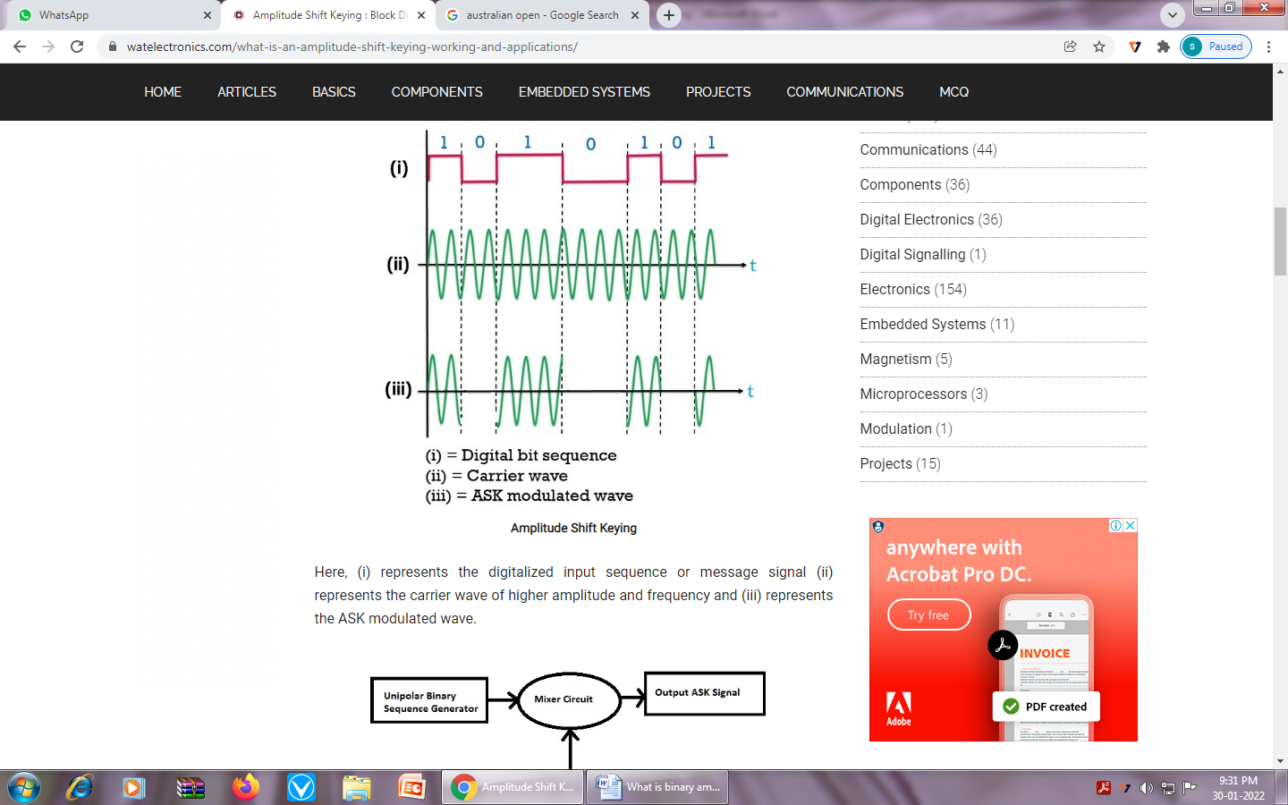

Here, (i) Represents the digitalized input sequence or message signal

(ii) Represents the carrier wave of higher amplitude and frequency

(iii) Represents the ASK modulated wave.

### ASK Demodulation is the process of reconstructing the original signal at the receiver level.

Applications of ASK are,

* Low-frequency RF applications
* [Home automation](https://www.elprocus.com/home-automation-systems-applications/) devices
* Industrial networks devices
* Wireless base stations
* Tire pressuring monitoring systems

**Procedure:**

**Modulation:**

Switch on the ASK Trainer Kit.

Connect Ground of modulator and CRO.

Connect the carrier signal o/p to carrier signal i/p of modulator.

Connect the data o/p to the data i/p of modulator.

Observe modulated signal on CRO.

**Demodulator:**

Connect ASK o/p to ASK i/p of demodulator.

Connect the carrier signal as /p to carrier signal i/p of demodulator.

Observe the demodulated signal and compare with that of data signal.

**Result:** Both ASK modulation and demodulation verified.

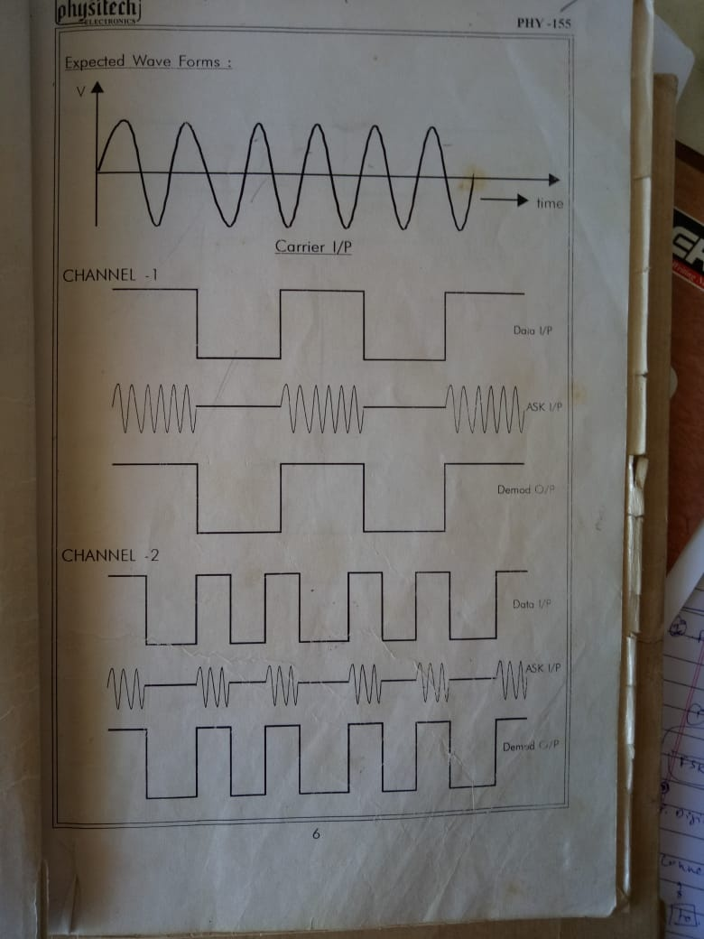

**Expt 2: Explore all ISP in your area/locality and select best Internet plan based on cost and performance.**

An Internet Service Provider (**ISP**) is a company that provides customers with Internet access.

Data may be transmitted using several technologies, including dial-up, DSL, cable modem, wireless or dedicated high-speed interconnects.

The services and service combinations may be unique to each ISP.

Finding best Internet service in your area and getting it installed.

**Step 1**: Check availability at your address.

**Step 2**: Determine how much Internet speed you need. Most households have multiple users and devices sharing the same WiFi.

**Step 3**: Decide if you want to bundle. Most Internet providers offer bundles including TV and home phone (and sometimes home security systems too). These packages are often more valuable for large households and families. However, some people save money by getting an Internet-only plan and a streaming service.

**Step 4**: Compare providers.

**Step 5**: Order and install.

**Expt 3: Test the download/upload speed and ISP in Computer/mobile phone.**

**For Computer and laptop**

* Open the Internet browser
* Type www.Google.com
* Search Internet speed test
* Select Speedtest by Ookla-The Global BroadbandSpeed Test
* Click on Go button
* Note down Upload and Download speed
* Verify ISP provider

**OR**

* Open the Internet browser
* Type www.Google.com
* Search Internet speed test

You'll be connected to Measurement Lab (M-Lab) and your IP address will be shared with them and processed by them in accordance with their privacy policy. M-Lab conducts the test and publicly publishes all test results to promote Internet research. Published information includes your IP address and test results, but doesn’t include any other information about you as an Internet user.

* Run Speed Test
* Note down Upload and Download speed

## To find ISP

1. Open Internet browser
2. Visit www.ipcheck.org or IP Lookup Tool
3. Your ISP will be displayed below your IP Address.

**For Mobile Phones**

Go to Play store and download and install Speedtest by Ookla app

* Click on Go button
* Note down Upload and Download speed
* Verify ISP provider

**OR**

* Open the Internet browser
* Type www.Google.com
* Search Internet speed test

You'll be connected to Measurement Lab (M-Lab) and your IP address will be shared with them and processed by them in accordance with their privacy policy. M-Lab conducts the test and publicly publishes all test results to promote Internet research. Published information includes your IP address and test results, but doesn’t include any other information about you as an Internet user.

* Run Speed Test
* Note down Upload and Download speed

## To find ISP

* Open the Internet browser
* Type www.whoismyisp.org
* Note down your ISP

**Expt 4: Assignment of IP address manually and automatically (Windows)**

**To Manually Assign an IP Address in Windows**

1. Go to Control Panel and select network and internet
2. Open the Network and Sharing Center window.

**OR**

Choose the link Local Area Connection On the right side of the window, and then click on Open the Network and Sharing Center.

1. Click on Local Area Connection(Ethernet link)
2. In the Ethernet Status dialog box, click the Properties button.

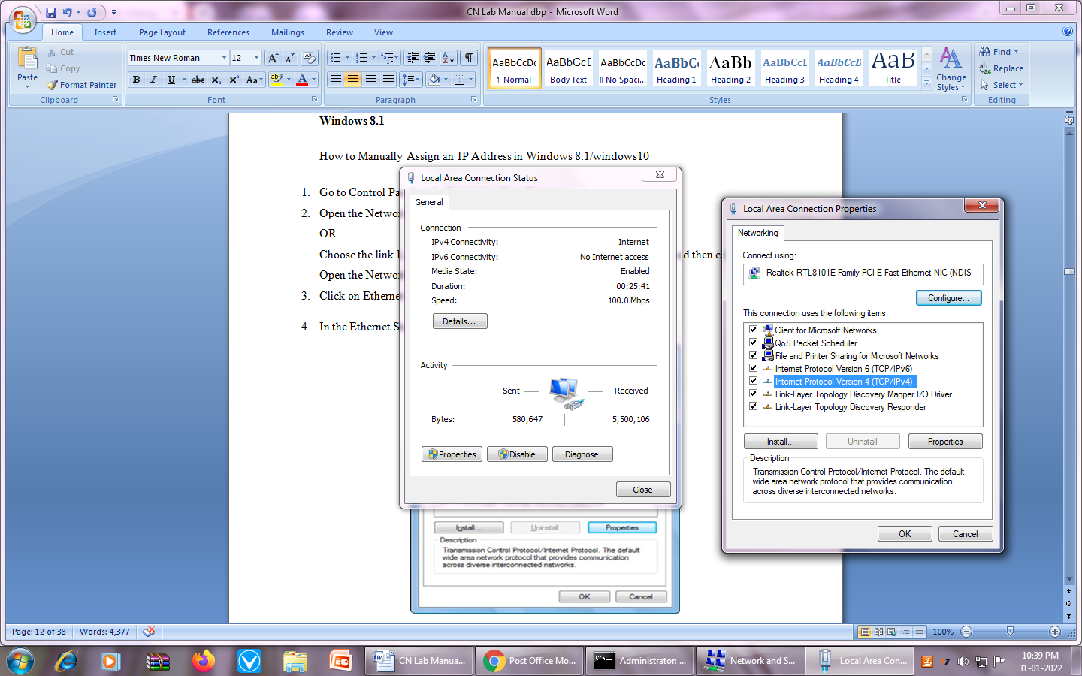

1. Select the service titled Internet Protocol Version 4 (TCP/IPv4).
2. Click the Properties button.

The dialog box labeled Internet Protocol Version 4 (TCP/IPv4) Properties appears.

1. Choose the option Use the Following IP Address.
2. Type the IP address.
3. Type a subnet mask.

For a local-area network (class C), the value is usually 255.255.255.0

Type the default gateway address.

The default gateway address is the IP address for the network’s router.

Ex: 192.168.1.1

1. Type the address of the preferred DNS server.

This value is obtained from your ISP.

1. Type the address for the alternative DNS server (Optional).

The alternate DNS server’s IP address is also something that your ISP must provide.

1. Click OK to close the Internet Protocol Version 4 (TCP/IPv4) Properties dialog box.
2. Close the other open dialog boxes and windows.

# To Automatically Assign an IP Address in Windows

1. Go to Control Panel and select network and internet
2. Open the Network and Sharing Center window.

OR

Choose the link Local Area Connection On the right side of the window, and then click on Open the Network and Sharing Center.

1. Click on Ethernet link
2. In the Ethernet Status dialog box, click the Properties button.

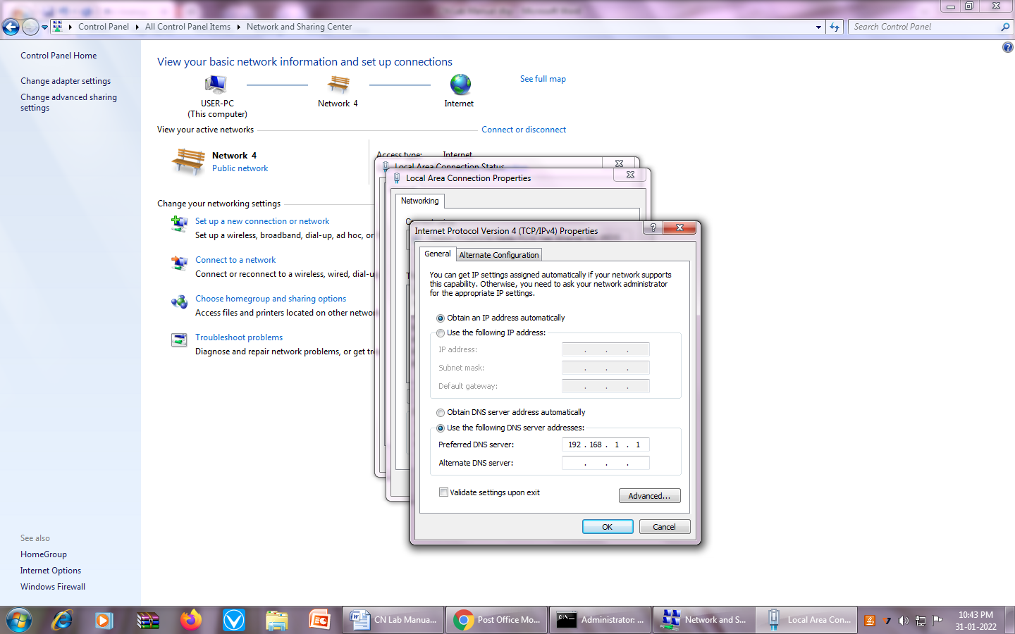

1. Select the service titled Internet Protocol Version 4 (TCP/IPv4).
2. Click the Properties button.

The dialog box labeled Internet Protocol Version 4 (TCP/IPv4) Properties appears.

1. Obtain an IP address automatically, click OK and close all the windows.

**Expt 5: Determine the IP Address Configuration of a Computer (Windows) and Test the Network Interface (Ping).**

**Method 1:**

1. Click the Start button, type cmd, and then press Enter.
2. The Command Prompt window will open, where you can type operating system commands.
3. Type ipconfig and press Enter.

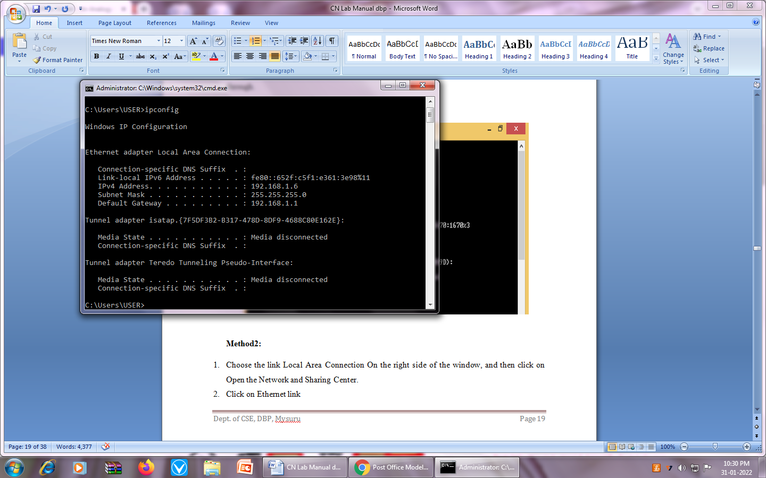

**Method 2:**

1. Choose the link Local Area Connection on the right side of the window, and then open the Network and Sharing Center.
2. Click on Ethernet link
3. In the Ethernet Status dialog box, click the Details button.
4. Note down the Network Connection Details

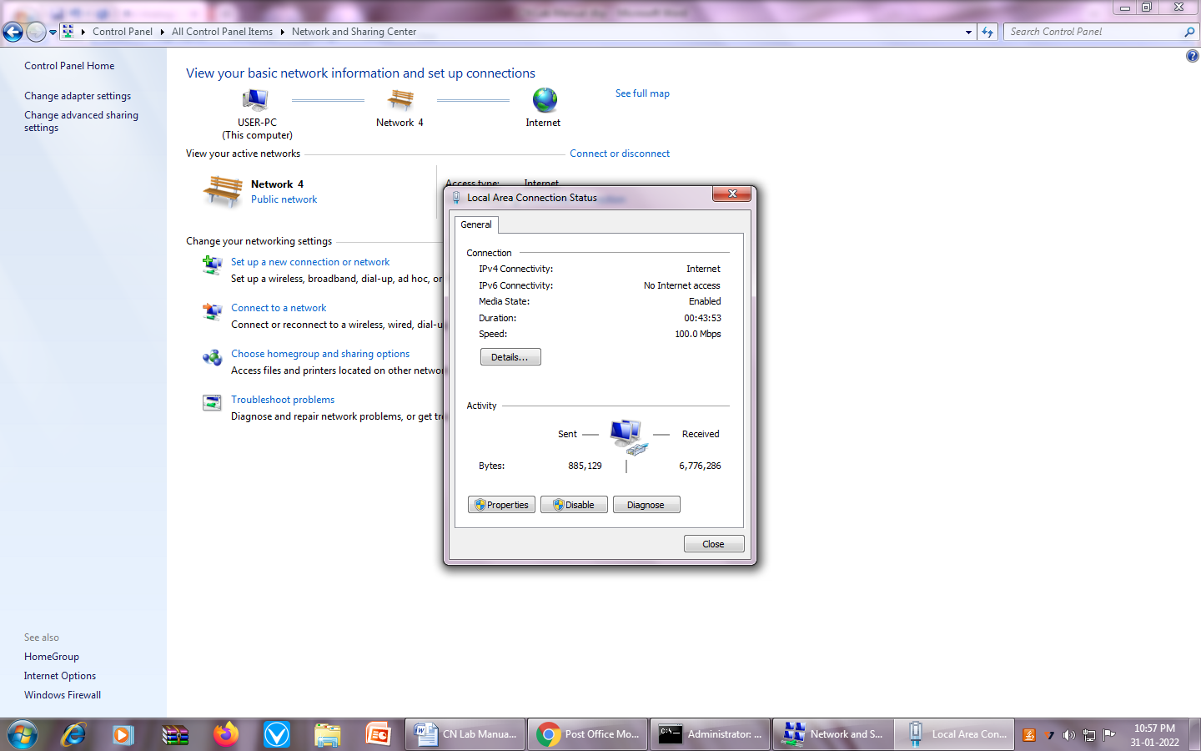

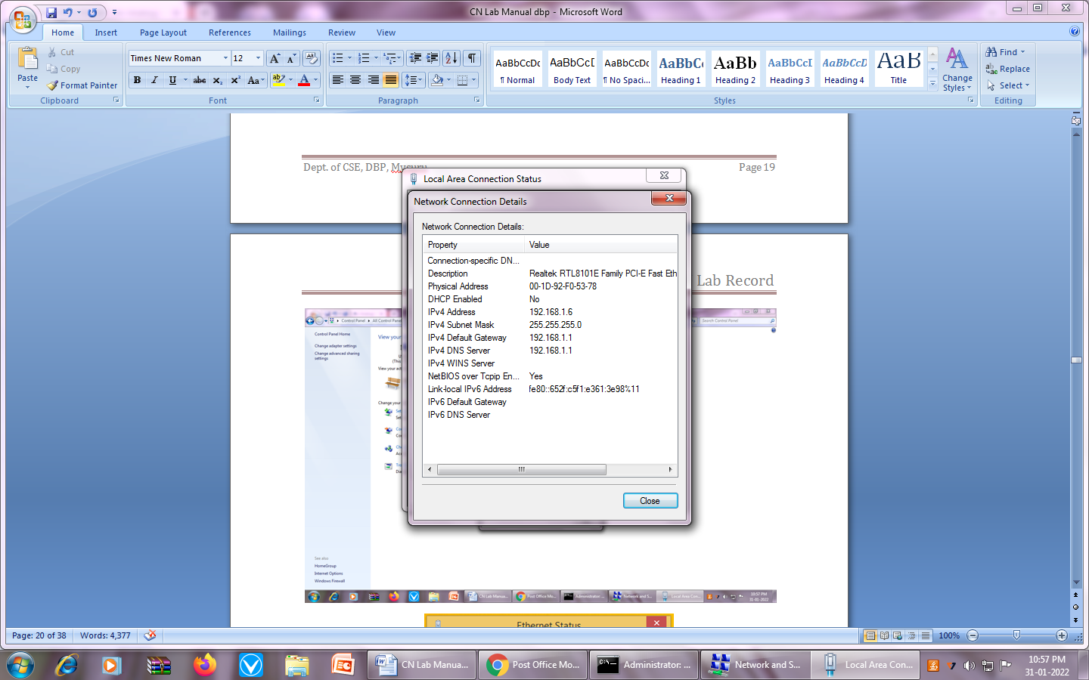

**How to run a ping network test**

1. Click the Start button, type “cmd”, and then press Enter.
2. Open the Command Prompt.
3. Type ping 192.168.1.25 (the IP address you'd like to ping)
4. Review the ping results displayed.

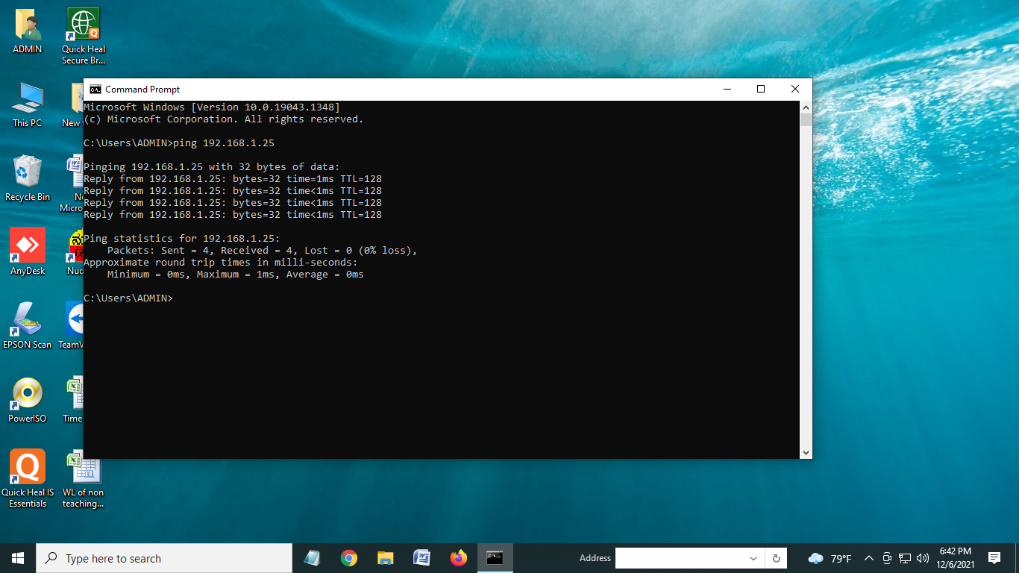

**Expt 6: Use pathping command to find actual path between source and destination with information about network latency/delay & network loss.**

The pathping command is **a** command-line network utility supplied in Windows 2000. It is used to locate spots that have network latency and network loss.

It is used to find actual path between source and destination with information about network latency/delay & network loss**.**

Pathping sends packets to each router on its path to destination and then calculates results based on the packet returned from each hop.

1. Open a Windows Command Prompt window.

At the command prompt, type, pathping <IP address>

pathping –n google.com

pathping -n 193.172.10.50

**Note**: You can interrupt pathping at any time by holding down the **CTRL**key, and pressing **C**on your keyboard.

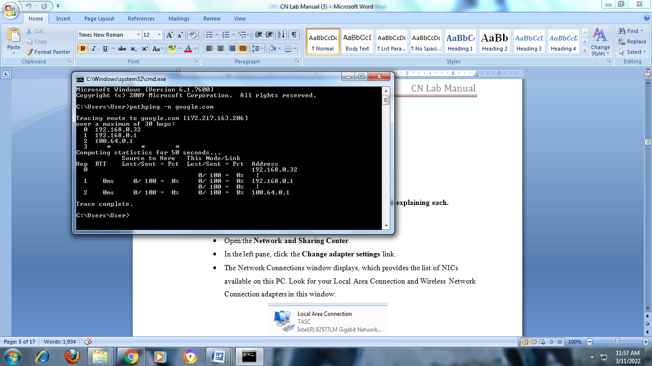

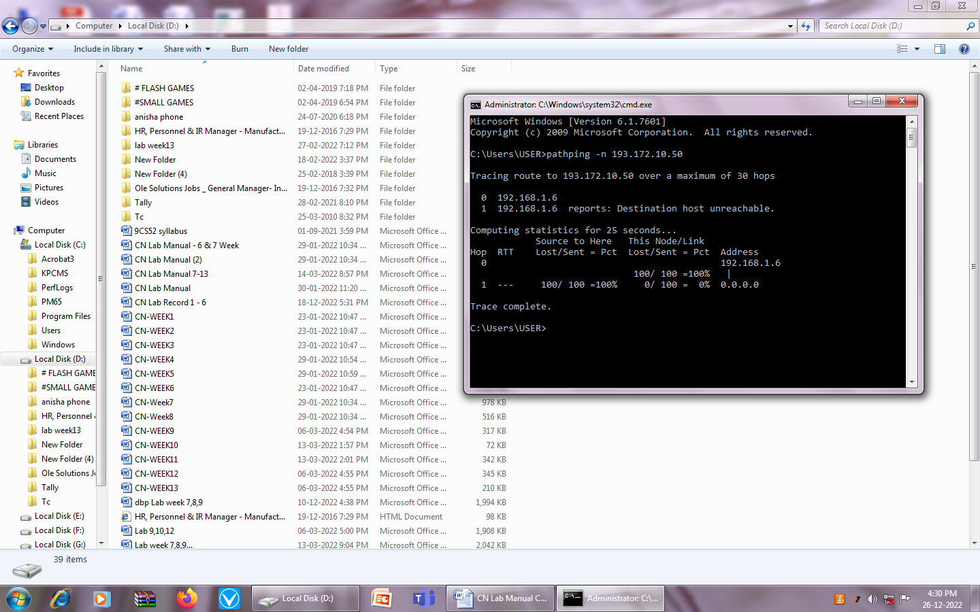

**Expt 7: Determine the MAC Address of a Host (PC and Phone).**

For PC:

* Open the command prompt.
* Type in ipconfig /all and press Enter.
* This will display your network configuration.
* Find your machine's Host Name and MAC Address.

For Phone:

Go to Settings -> About Phone ->Status -> MAC Address.

**Expt 8: View Wired NIC Information.**

#### Step 1: Use the Network and Sharing Center.

* Open the **Network and Sharing Center**.
* In the left pane, click the **Change adapter settings** link.
* The Network Connections window displays, which provides the list of NICs available on this PC. Look for your Local Area Connection and Wireless Network Connection adapters in this window.
* On the Network Connections window, select and right-click the **Local Area Connection** option to display the drop-down list. If the NIC is disabled, enable it, and then click the **Status** option.
* The Local Area Connection Status window will open. This window displays information about your wired connection to the LAN.
* Click **Details** to view the address information for your LAN connection.

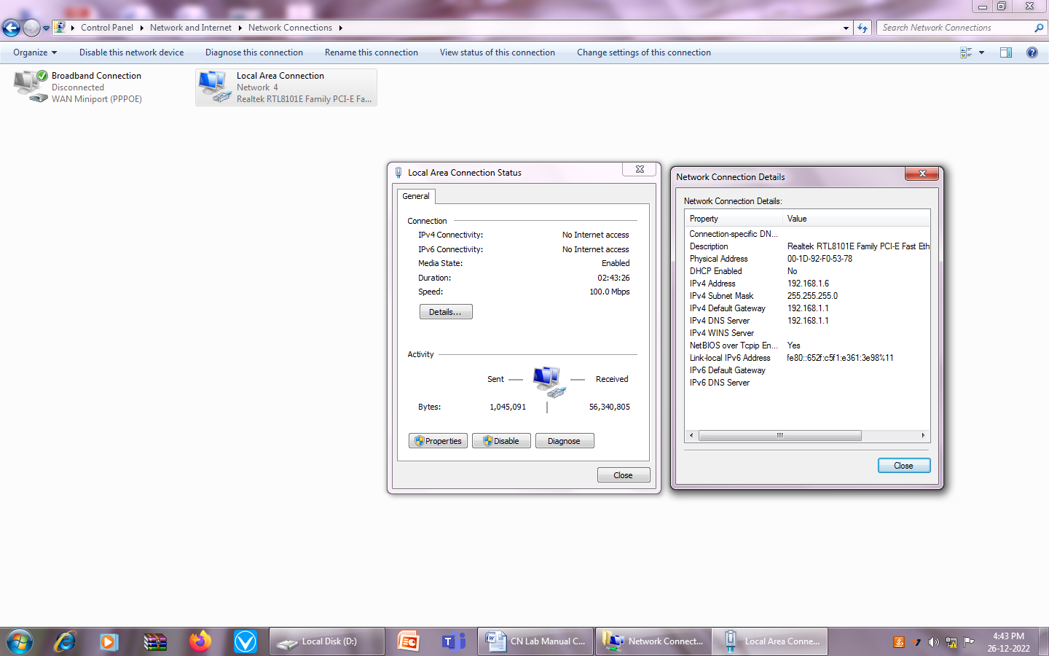

**Expt 9: Crimping of RJ45: Straight and Cross.**

Procedure: Using a Crimping Tool

1. Strip the cable back 1 inch from the end.

### Untwist and straighten the wires inside of the cable.

1. Arrange the wires into the right order
2. Cut the wires into an even line 1⁄2 inch (1.3 cm) from sheathing.
3. Insert the wires into the RJ-45 connector.
4. Stick the connector into the crimping part of the tool and squeeze twice.
5. Remove the cable from the tool and check that all of the pins are down.

### Straight Cable: Used to connect different type of devices.

1) Connect a computer to a switch/hub's normal port.  
2) Connect a computer to a cable/DSL modem's LAN port.  
3) Connect a router's WAN port to a cable/DSL modem's LAN port.  
4) Connect a router's LAN port to a switch/hub's uplink port.

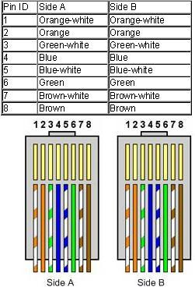

### Crossover Cable: used to connect same type of devices.

1) Connect 2 computers directly.  
2) Connect a router's LAN port to a switch/hub's normal port.

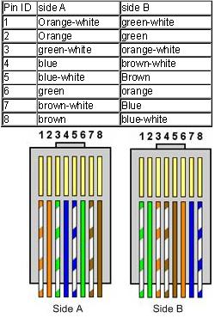

**Expt 10. Build a physical Ethernet LAN and demonstrate file sharing.**

Procedure:

1. Set IP address for System 1

* Open network and sharing center from control panel
* change adapter settings
* right click on ethenet -> select properties
* select ipv4 -> click on it and select properties
* set IP address as 192.168.1.2
* click on ok

Repeat the steps for System 2 (Note: Set IP address to 192.168.1.3)

2. For System1 and System2 do the following steps:-

* Open (This pc or computer or my computer) in your system
* Select d drive: -> right click -> select properties -> click on sharing tab
* Click advanced sharing
* Check (Tick mark) share this Drive/folder
* Click permissions and allow all permissions/required task to be done for sharing
* Apply -> ok
* Apply ->ok
* Close

3. Go to Run window (Press windows + r)

Type (self test)

1. In System1 - ping 192.168.1.2
2. In System2 - ping 192.168.1.3

4. Next, ping for other system

1. In system1 give system2 IP address - Ping 192.168.1.3
2. In system2 give system1 IP address - Ping 192.168.1.2

5. For sharing documents from System1 to System2 and from System2 to System1

Press windows+r and do:

1. In system1 give system2 ip address like \\192.168.1.3
2. In system2 give system1 ip address like \\192.168.1.2

You will have access to the shared Drive/folder.

**Expt 11: Build a physical Ethernet LAN and demonstrate Printer sharing.**

Procedure:

Install printer software in any one of the systems.

1. Click on start -> devices and printers

* Right click on the installed printer software
* Select printer properties -> sharing
* Click on share this printer

Apply

Ok

In installed system (IP address: 192.168.1.2)

2. In another system (IP address: 192.168.1.3)

* Click on start -> devices and printers -> add a printer -> stop

The printer that I want isn’t listed

* Next
* Select a shared printer by name
* Type IP address of printer installed system in another systems (\\192.168.1.2)
* After this it shows a installed printer name
* Select it -> ok -> ok.
* Print a test page.

**Expt 12: Install and configure NIC.**

**Network Interface Card** (NIC) is a computer hardware component that connects a computer to a computer network.

Procedure:

1. Remove the AC power cord and Open the computer case.
2. Find an available Peripheral Component Interconnect (PCI) slot on the motherboard.

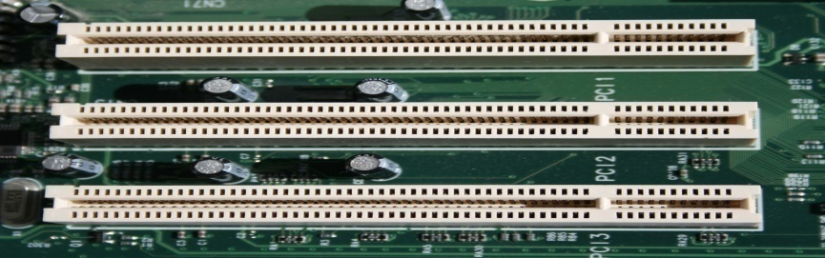

1. Place the cord properly on PCI slot.

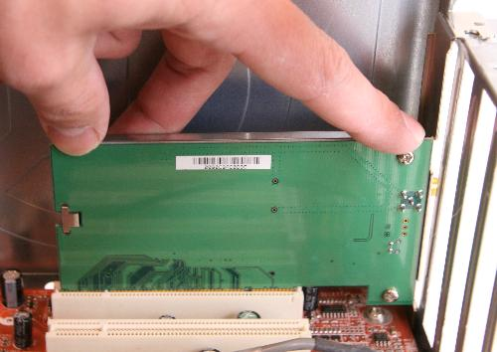

1. Screw the card to the computer frame and Close the computer case.
2. Plug your computer in and power it up.
3. Click Start, and then click Control Panel.
4. In Category View (Large Icon). Or Right click on This PC icon on Desktop and select Manage
5. Click the Device Manager Button.
6. Double-click Network Adapters.

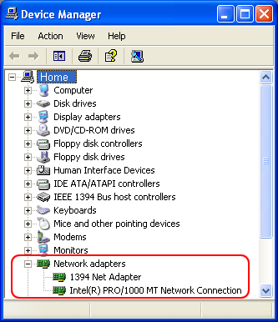

1. Beneath it should appear the name of your Ethernet card.
2. Next, double click the name of your Ethernet adapter.
3. If the text in the "Device Status" box says "This device is working properly.", then you successfully installed the card and are finished.
4. If the text in the "Device status" box doesn't say "This device is working properly." Click the Troubleshoot Button and follow instructions.

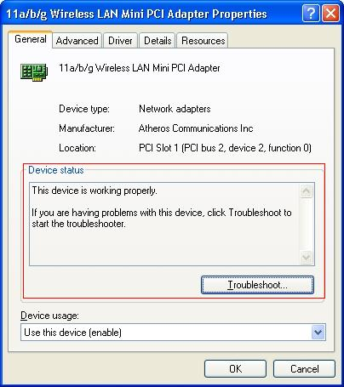

**Expt 13: Install and configure wireless router.**

**Setting up BSNL broadband Wireless Router**

**Step 1** Connect the modem to power supply and one LAN port to the computer.

**Step 2** Find the IP address of your modem (default IP address is **192.168.1.1**).

**Step 3** Login to this address. Default is **admin (username)** and fast@1234 **(password).**

**Step 4** After login Device status page will open up.

**Step 5** Go to Status 🡪Enter Device Info

**Step 5** Go to Network🡪Internet🡪WAN Configuration – Configure the Router

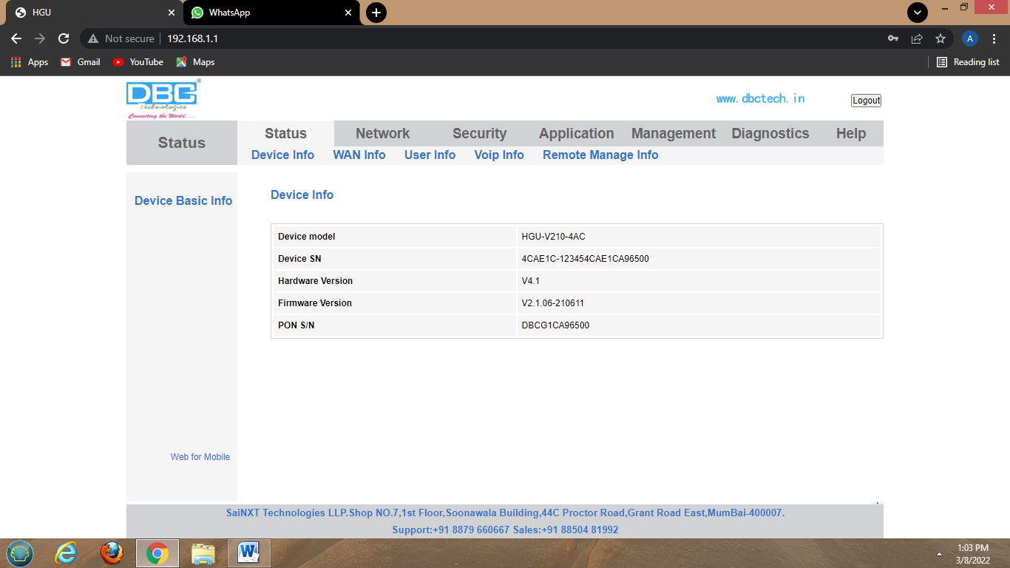

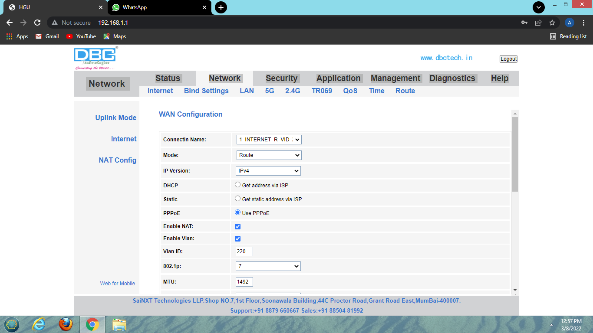

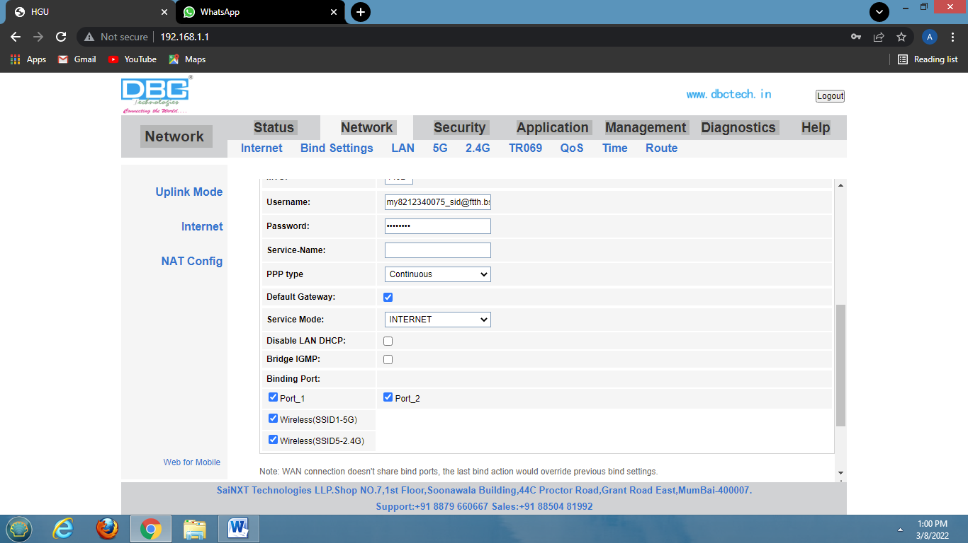

**PART - B**

**Expt 14: Design, Configure and Demonstrate Star Topology (Simulation) using Cisco Packet Tracer.**

**Procedure**

* Go to Cisco Packet Tracer.
* Click on the End Devices and deploy 6 PCs.
* Click on the Network Devices and deploy 2960 switch
* Click on the connection category and select the Copper Straight-Through cable type to connect PC to Switch
* From the pop-up menu select the Fast Ethernet interface to connect switch and PC.
* Click on PC, go to desktop and select IP configuration and assign IP address to all the individual PCs.
* Go to the command and ping all the PCs. Ex: ping 192.168.1.1
* Go to tool bar & take a packet (PDU) & place it into source device and mention the destination device.
* We can start the simulation & we can see the message going from one PC to another PC.

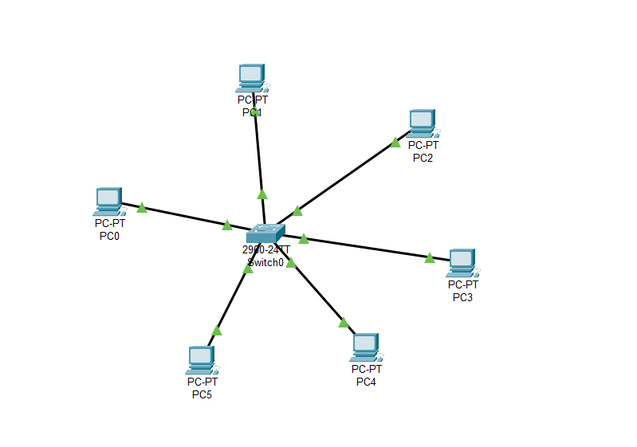

**Expt 15: Design, Configure and Demonstrate Bus Topology (Simulation) using Cisco Packet Tracer.**

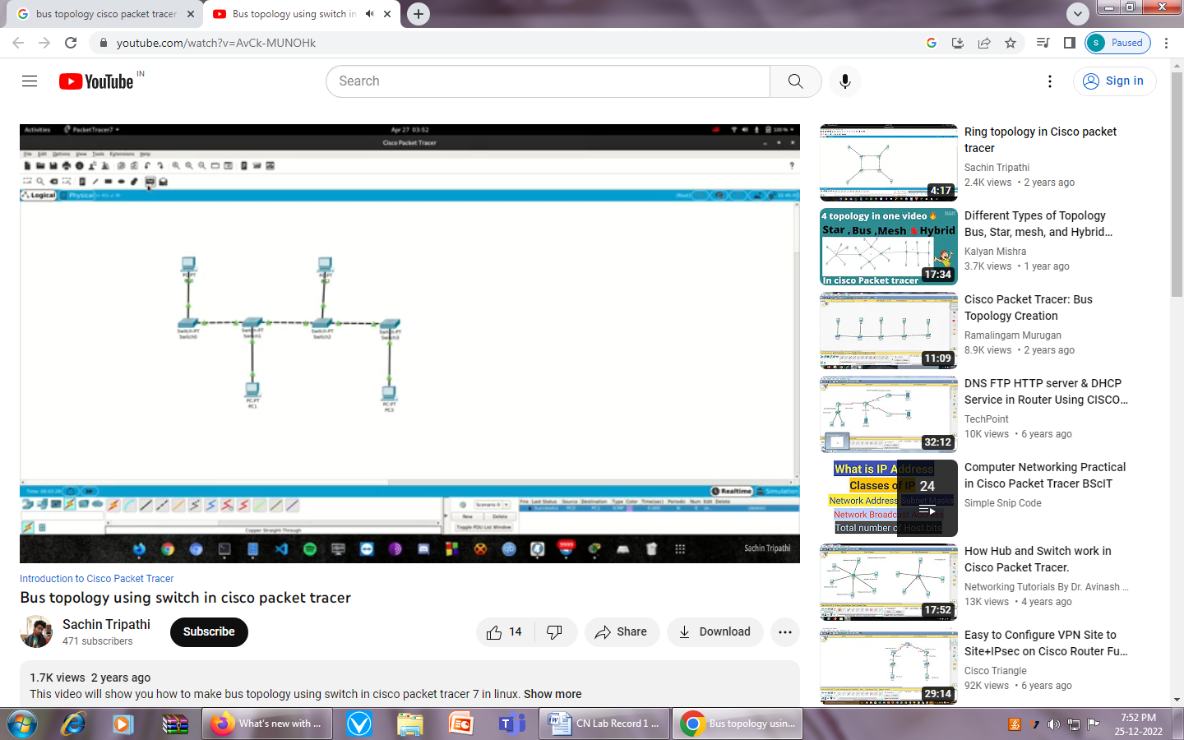

**Procedure**

* Go to Cisco Packet Tracer.
* Click on the End Devices and deploy 4 PCs.
* Click on the Network Devices and deploy four 2960 switches
* Click on the connection category and Select a Copper Cross-Over cable to connect the switches.
* From the pop-up menu select the FastEthernet0/1 interface to connect switch0 and switch1, select the FastEthernet0/2 interface to connect switch1 and switch2, select the FastEthernet0/3 interface to connect switch2 and switch3
* Click on the connection category and select the Copper Straight-Through cable type to connect PC to Switch
* From the pop-up menu select the Fast Ethernet interface to connect switch and PC.
* Click on PC, go to desktop and select IP configuration and assign IP address to all the individual PCs.
* Go to the command and ping all the PCs. Ex: ping 192.168.1.1
* Go to tool bar & take a packet (PDU) & place it into source device and mention the destination device.
* We can start the simulation & we can see the message going from one PC to another PC.

**Expt 16: Design, Configure and Demonstrate Ring Topology (Simulation) using Cisco Packet Tracer.**

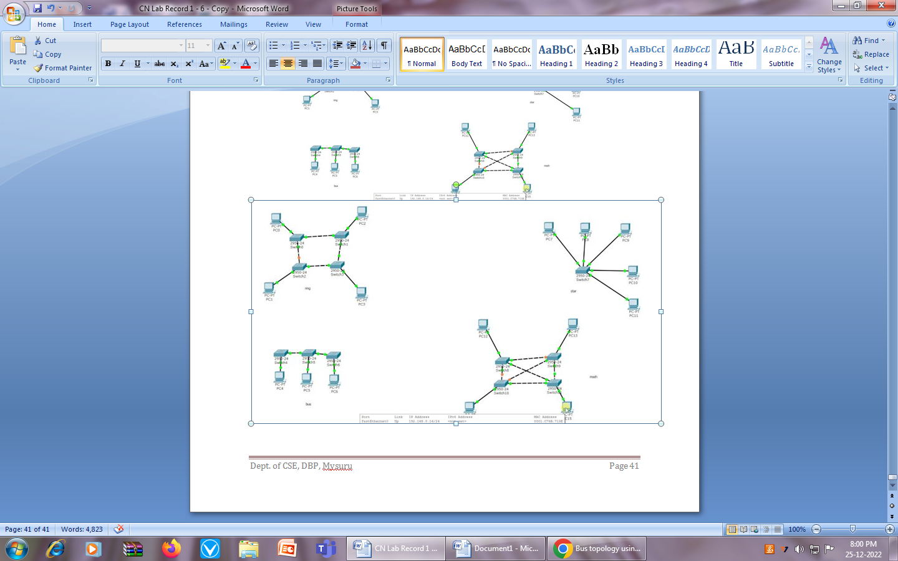

**Procedure**

* Go to Cisco Packet Tracer.
* Click on the End Devices and deploy 4 PCs.
* Click on the Network Devices and deploy four 2960 switches
* Click on the connection category and Select a Copper Cross-Over cable to connect the switches.
* From the pop-up menu select the FastEthernet0/1 interface to connect switch0 and switch1, select the FastEthernet0/2 interface to connect switch1 and switch2, select the FastEthernet0/3 interface to connect switch2 and switch3
* Click on the connection category and select the Copper Straight-Through cable type to connect PC to Switch
* From the pop-up menu select the Fast Ethernet interface to connect switch and PC.
* Click on PC, go to desktop and select IP configuration and assign IP address to all the individual PCs.
* Go to the command and ping all the PCs. Ex: ping 192.168.1.1
* Go to tool bar & take a packet (PDU) & place it into source device and mention the destination device.
* We can start the simulation & we can see the message going from one PC to another PC.

**Expt 17: Design, Configure and Demonstrate Mesh Topology (Simulation) using Cisco Packet Tracer.**

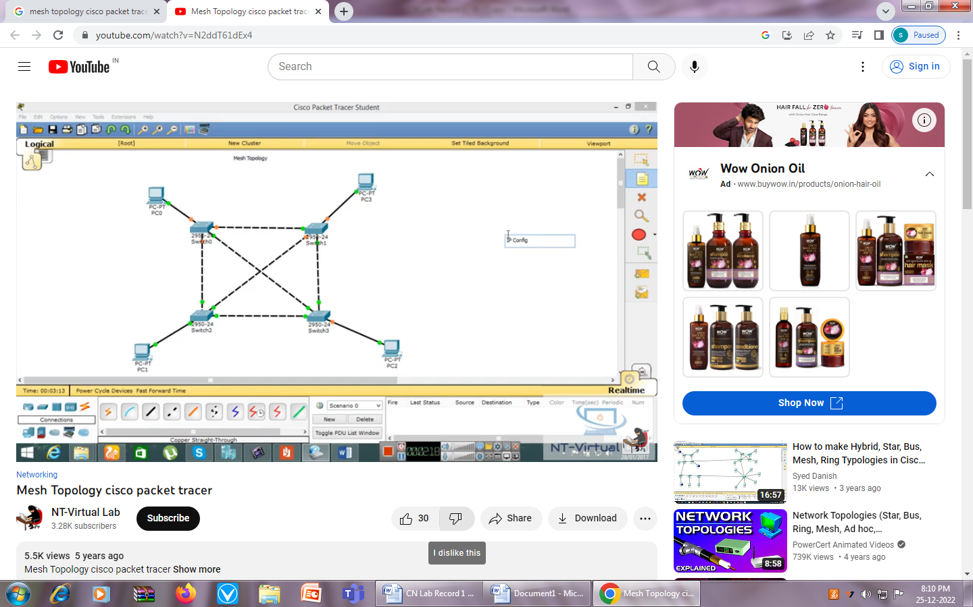

**Procedure**

* Go to Cisco Packet Tracer.
* Click on the End Devices and deploy 4 PCs.
* Click on the Network Devices and deploy four 2960 switches
* Click on the connection category and Select a Copper Cross-Over cable to connect the switches.
* From the pop-up menu select the FastEthernet0/1 interface to connect switch0 and switch1, select the FastEthernet0/2 interface to connect switch1 and switch2, select the FastEthernet0/3 interface to connect switch2 and switch3
* Click on the connection category and select the Copper Straight-Through cable type to connect PC to Switch
* From the pop-up menu select the Fast Ethernet interface to connect switch and PC.
* Click on PC, go to desktop and select IP configuration and assign IP address to all the individual PCs.
* Go to the command and ping all the PCs. Ex: ping 192.168.1.1
* Go to tool bar & take a packet (PDU) & place it into source device and mention the destination device.
* We can start the simulation & we can see the message going from one PC to another PC.

**Expt 18: Create a simple Ethernet network (Ex: 3 hosts and a switch). Observe traffic behavior on the network and observe data flow of ARP broadcasts and pings. (Cisco Packet Tracer)**

* Go to Cisco Packet Tracer.
* Click on the End Devices and deploy 3 PCs.
* Click on the Network Devices and deploy 2960 switch
* Click on the connection category and select the Copper Straight-Through cable type to connect PC to Switch.
* Click on PC, go to desktop and select IP configuration and assign IP address to all the individual PCs.
* Go to the command prompt and ping all the PCs. Ex: ping 192.168.1.1
* Go to tool bar & take a packet (PDU) & place it into source device and mention the destination device.
* Start the simulation and see the message going from one PC to another PC.
* Go to the command prompt Type arp –a to view the ARP table
* Go to tool bar and select inspect(search icon) tool and place it on PC and select arp table to view ARP information

**Expt 19: Build a simple peer-to-peer network and assign various IPv4 addresses to hosts and observe the effects on network communication (Cisco Packet Tracer)**

* Go to Cisco Packet Tracer.
* Click on the End Devices and deploy 2PCs.
* Click on the connection category and select the Copper Cross-over cable type to connect PCs
* Click on PC, go to desktop and select IP configuration and assign IP address to all the individual PCs.
* Go to the command prompt and ping all the PCs. Ex: ping 192.168.1.1
* Go to tool bar & take a packet (PDU) & place it into source device and mention the destination device.
* We can start the simulation & we can see the message going from one PC to another PC.

**Expt 20: Create a simple Ethernet network, configure IP address and ping across to test the network. (Cisco Packet Tracer)**

* Go to Cisco Packet Tracer.
* Click on the End Devices and deploy 3 PCs.
* Click on the Network Devices and deploy 2960 switch
* Click on the connection category and select the Copper Straight-Through cable type to connect PC to Switch.
* Click on PC, go to desktop and select IP configuration and assign IP address to all the individual PCs.
* Go to the command prompt and ping all the PCs. Ex: ping 192.168.1.1
* Go to tool bar & take a packet (PDU) & place it into source device and mention the destination device.
* We can start the simulation & we can see the message going from one PC to another PC.

**Expt 21: Demonstrate Subnetting of a network using Simulator (Cisco Packet Tracer)**

Subnetting

* It is the process of dividing a network into two or more smaller networks. It increases the network performance and routing efficiency.
* In class C network, the first three octets (24 bits) represents network address and the last octet (8 bits) represents the host address. Therefore the subnet address can be created by modifying the bits of the last octet.
* When subnets are created, the number of subnets is a power of 2. The value of the exponent gives the number of bits that represent the subnet mask.

Example: For 192.168.1.1 to 192.168.1.255, we can create 2 subnets with subnet mask 192.168.1.128

First subnet will have address between 192.168.1.1 and 192.168.1.127

Second subnet will have address between 192.168.1.129 and 192.168.1.254

Note: First and last bits will not be used.

* Go to Cisco Packet Tracer.
* Click on the End Devices and deploy 6 PCs.
* Click on the Network Devices and deploy two switches (2960) and one router (2911) and design a network as shown in the figure.

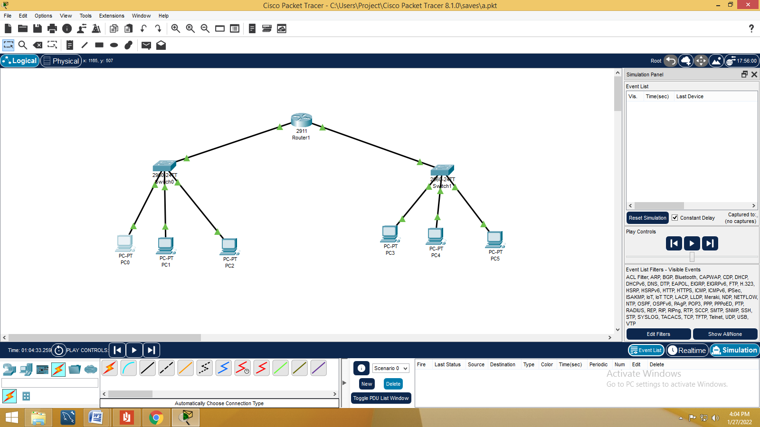

* Click on the Cables and select Straight through connection type to connect PC to Switch and switch to router
* Click on PC, go to desktop and select IP configuration and assign IP address to all the individual PCs.
* Go to the command prompt and ping all the PCs. Ex: ping 192.168.1.1

**For first Network**

|  |  |  |  |
| --- | --- | --- | --- |
|  | PC1 | PC2 | PC3 |
| **IP ADDRESS** | 192.168.1.1 | 192.168.1.2 | 192.168.1.3 |
| **SUBNET MASK** | 255.255.255.128 | 255.255.255.128 | 255.255.255.128 |
| **DEFAULT GATEWAY** | 192.168.1.4 | 192.168.1.4 | 192.168.1.4 |

**For Second Network**

|  |  |  |  |
| --- | --- | --- | --- |
|  | PC1 | PC2 | PC3 |
| **IP ADDRESS** | 192.168.1.129 | 192.168.1.130 | 192.168.1.131 |
| **SUBNET MASK** | 255.255.255.128 | 255.255.255.128 | 255.255.255.128 |
| **DEFAULT GATEWAY** | 192.168.1.132 | 192.168.1.132 | 192.168.1.132 |

For Router

* Click on router
* Go to config
* Click on GigabitEthernet0/0
* Check ON the check box in the right corner and assign IP Address : 192.168.1.4

And subnet mask: 255.255.255.128

* Click on GigabitEthernet0/1
* Click the on check box in the right corner and assign IP Address : 192.168.1.132

And subnet mask: 255.255.255.128

**Expt 22: Demonstrate how to connect to FTP server using simulator. (Cisco Packet Tracer).**

* Go to Cisco Packet Tracer.
* Deploy 3 PC, one Switch, one Router and one server.
* Click on the Cables and select straight through connection type to connect PCs to Switch, Switch to Router and Router to Server.

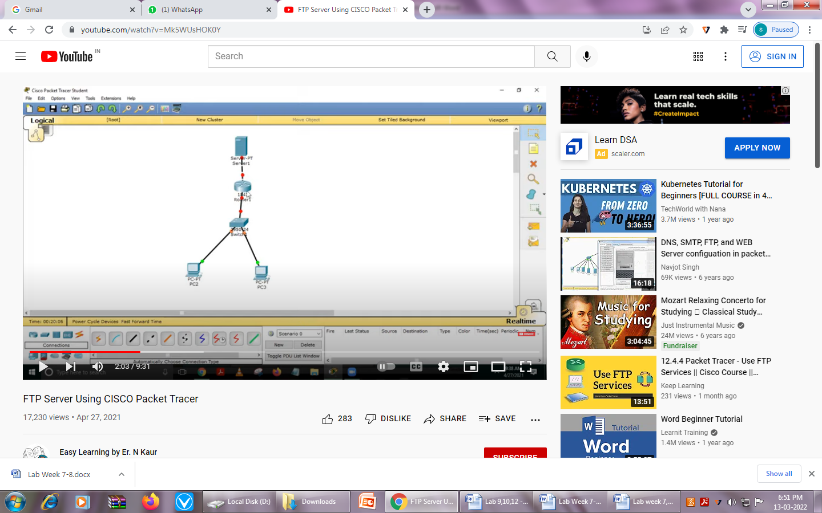

* Click on PC, go to desktop and select IP configuration and assign IP address to all the individual PCs and a server.

|  |  |  |  |  |
| --- | --- | --- | --- | --- |
|  | PC1 | PC2 | PC3 | Server |
| **IP ADDRESS** | 192.168.1.2 | 192.168.1.3 | 192.168.1.4 | 10.10.10.2 |
| **SUBNET MASK** | 255.255.255.0 | 255.255.255.0 | 255.255.255.0 | 255.0.0.0 |
| **DEFAULT GATEWAY** | 192.168.1.1 | 192.168.1.1 | 192.168.1.1 | 10.10.10.1 |

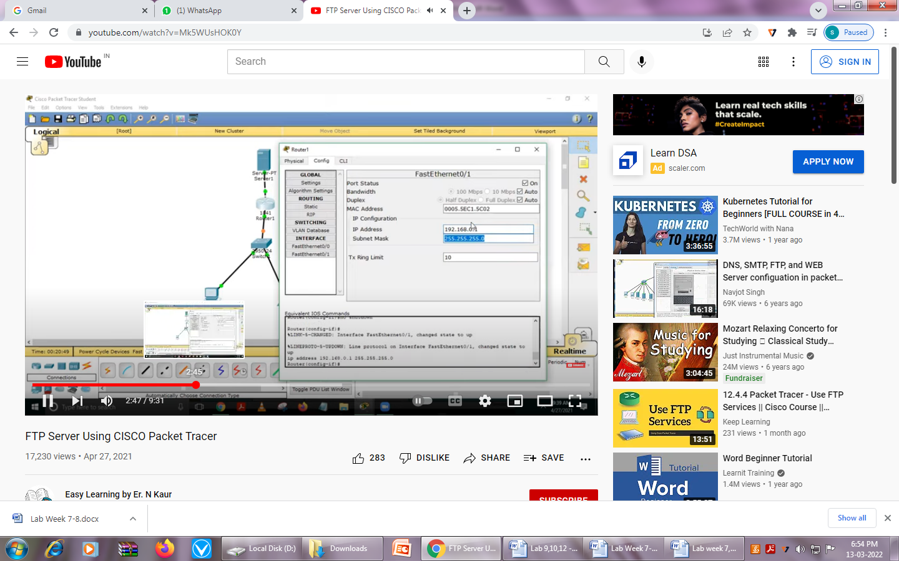

* Click on Server, go to desktop and select IP configuration and assign IP address to the server.
* Go to Server🡪Config🡪Display Name – FTP server
* Go to Server🡪Services🡪Select FTP

Set Username: DBP Password:CS

Select all permissions 🡪Add 🡪Close

* Go to one of the PCs🡪Desktop🡪Command Prompt🡪ping the other PCs and server
* To connect to FTP server, give the following commands at the command prompt
* >ftp
* >ftp 10.10.10.2

This will connect you to FTP server.

**Expt 23: Demonstrate implementing simple static routing using simulator. (Cisco Packet Tracer).**

* Go to Cisco Packet Tracer.
* Deploy 4 PC, 2 switch and 2 routers as shown in the figure.
* Select Straight through Cable and connect PC to Switch and switch to router. Select Cross over Cable and connect router to router.
* Click on PC, go to desktop and select IP configuration and assign IP address to all the individual PCs and a Routers
* Go to tool bar & take a packet (PDU) & place it into source device (PC) and mention the destination device (Server).
* We can start the simulation & we can see the message going from one PC to another Server.

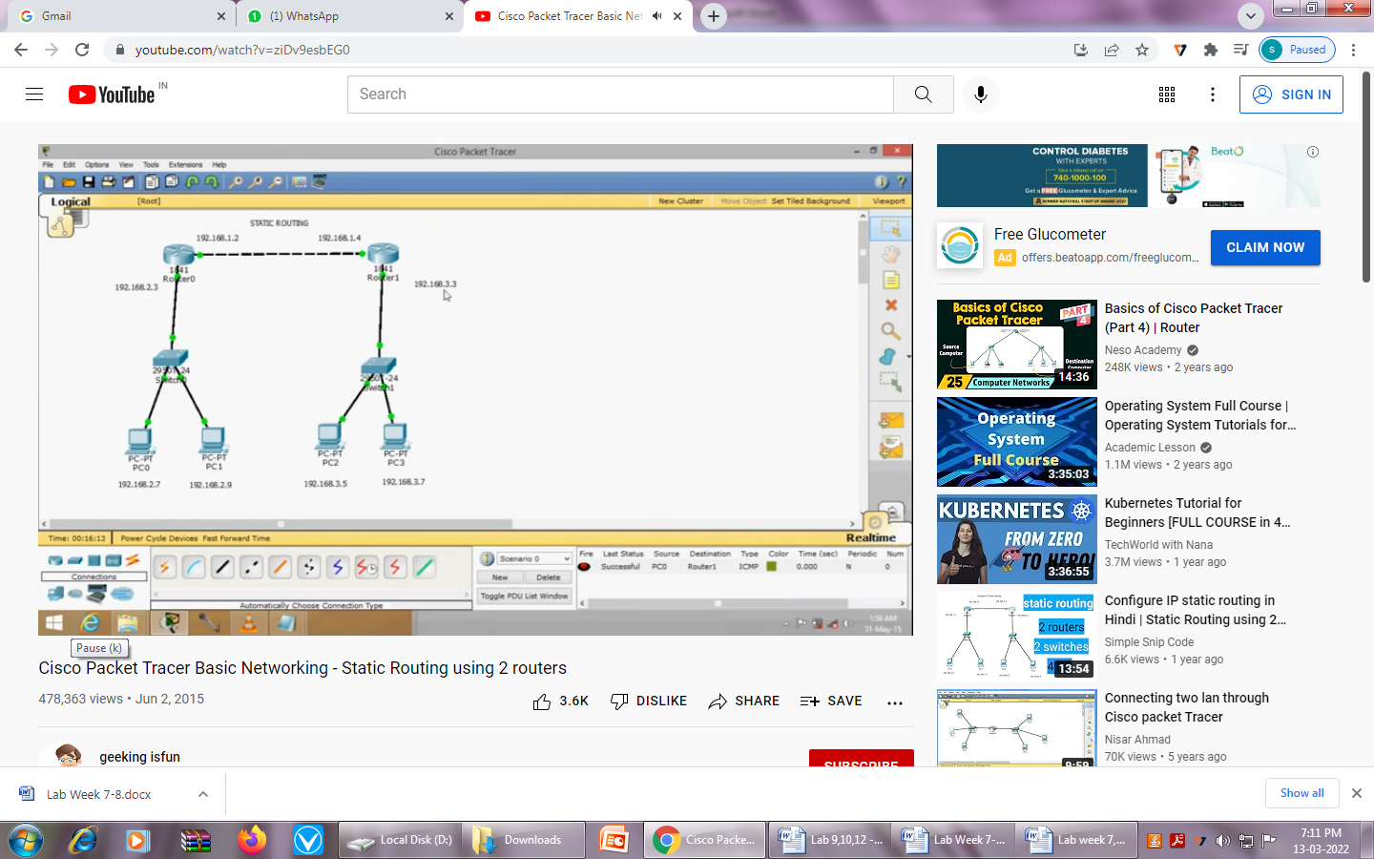

|  |  |  |  |  |
| --- | --- | --- | --- | --- |
|  | PC1 | PC2 | Router1  (Interface 0) | Router1  (Interface 1) |
| **IP ADDRESS** | 192.168.2.7 | 192.168.2.9 | 192.168.2.3 | 192.168.1.2 |
| **SUBNET MASK** | 255.255.255.0 | 255.255.255.0 | 255.255.255.0 | 255.255.255.0 |
| **DEFAULT GATEWAY** | 192.168.2.3 | 192.168.2.3 |  |  |

|  |  |  |  |  |
| --- | --- | --- | --- | --- |
|  | PC3 | PC4 | Router2  (Interface 0) | Router2  (Interface 1) |
| **IP ADDRESS** | 192.168.3.5 | 192.168.3.7 | 192.168.3.3 | 192.168.1.4 |
| **SUBNET MASK** | 255.255.255.0 | 255.255.255.0 | 255.255.255.0 | 255.255.255.0 |
| **DEFAULT GATEWAY** | 192.168.3.3 | 192.168.3.3 |  |  |

For Router1 and Router2

* Click on Router
* Go to config
* Click on Static and mention Network, Mask and Next Hop

|  |  |  |
| --- | --- | --- |
|  | Router1 | Router2 |
| Network | 192.168.3.0 | 192.168.2.0 |
| Mask | 255.255.255.0 | 255.255.255.0 |
| Next Hop | 192.168.1.4 | 192.168.1.2 |

**Expt 24: Create a client – server model in simulator and observe the client interaction between the server and PC using simulator (Cisco Packet Tracer).**

* Go to Cisco Packet Tracer.
* Deploy 4 PCs, a switch a Server as shown in figure.

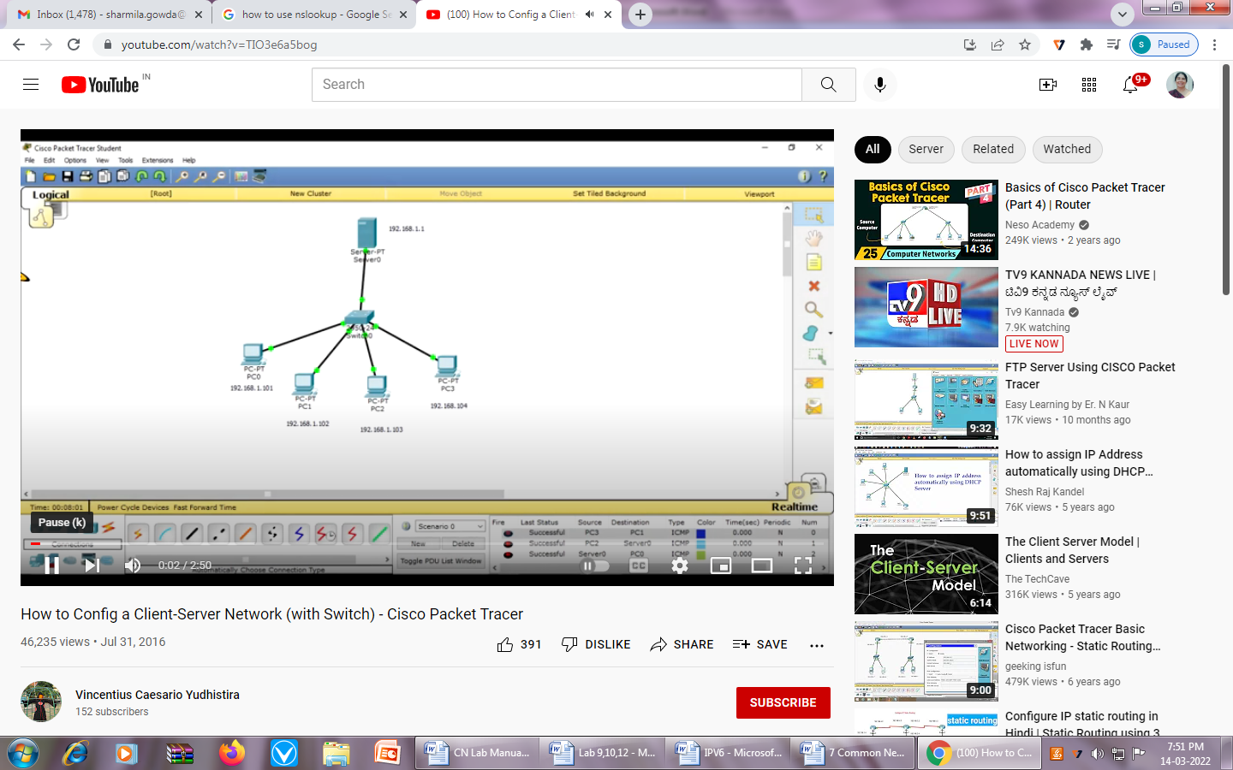

* Click on server 🡪 config 🡪 FastEthernet0, set IP address to192.168.1.1
* Click on config🡪Settings, set gateway - 192.168.1.1
* Click on Service tab select DHCP, click on Service “On” (Radio Button)
* Set Start IP address to 192.168.1.101 (set Host part to 101)
* Set Maximum Number of Users to 24
* Save and close.

Go to each PC 🡪Desktop🡪 click on DHCP “On” (Radio Button)

Automatically IP address will be configured.

* Now communicate between PCs(clients), client to server and server to client by simulation.

**STUDY EXPERIMENTS**

**Expt 1: Explore Bluetooth, Wi-Fi, NFC in your Smartphone and note their key technical attributes (Radio spectrum band, range, path loss, throughput, bandwidth etc). (Study Experiment)**

**Bluetooth** is a short-range wireless communication technology standard. It is used for exchanging data between fixed and mobile devices over short distances using [UHF](https://en.wikipedia.org/wiki/Ultra_high_frequency) [radio waves](https://en.wikipedia.org/wiki/Radio_wave).

**Wi-Fi** is the wireless technology used to connect computers, tablets, smart phones and other devices to the Internet.

**Near field communication**, abbreviated **NFC**, is a form of contactless communication between devices like smart phones or tablets.

**Near Field Communication** (NFC) technology allows users to make secure transactions, exchange digital content, and connect electronic devices with a touch. Today NFC is most commonly used for **contactless payment**.

**Path loss**, or path attenuation, is the reduction in power density ([attenuation](https://en.wikipedia.org/wiki/Attenuation_(electromagnetic_radiation))) of an [electromagnetic wave](https://en.wikipedia.org/wiki/Electromagnetic_wave) as it propagates through space.

Network **throughput** is the amount of data moved successfully from one place to another in a given time period, and it is measured in bits per second (bps)

|  |  |  |  |
| --- | --- | --- | --- |
|  | **Bluetooth** | **Wi-Fi** | **NFC** |
| Frequency Range | 2.400 GHz and 2.483 GHz | 2.4 GHz and 5 GHz | 13.56 MHz |
| Range | 10 meters | 100 meters | 10 centimeters |
| Throughput | 0.7-2.1 Mbit/s | 450 Mbps or 600 Mbps | It supports data rate of 106 Kbps , 212 kbps and 424 Kbps |
| Bandwidth | 1 MHz | 22 MHz | 14KHz |

**Expt 2: My Protocol Rules Objectives (Study Experiment)**

**a) Relate computer network protocols to the rules that you use every day for various forms of communication.**

Before beginning to communicate with each other, we establish rules or agreements to govern the conversation. These rules, or protocols, must be followed for the message to be successfully delivered and understood.

Ex: Choosing of Languages – Verbal, non verbal, etc

Communication medium – Person to person communication, over Telephone, messaging, chatting, etc

**b) Define the rules that govern how to communicate in a group of students.**

* An identified sender and receiver
* Agreed upon method of communicating
* Common language and grammar
* Speed and timing of delivery
* Confirmation or acknowledgement requirements

1. Ask questions
2. Be prepared for class
3. Share new ideas
4. Keep your hands to yourself
5. Keep your workspace tidy
6. Be kind
7. Always do your best
8. Be a good friend
9. Be on time
10. Share with others
11. Use equipment properly
12. Help keep the classroom tidy
13. Have a good attitude
14. Use positive language
15. Follow the dress code
16. Listen with your ears and your eyes
17. Contribute to discussions
18. Be respectful of others ideas
19. Be creative
20. Be honest
21. Use technology appropriately

**c) Play the communication game**

The game “Chinese Whispers” was played with different groups of students.

Students participated enthusiastically and enjoyed playing the game.

They came to know of the problems that might occur between sender and receiver.

Sender itself not transmitting properly, the intermediate nodes not doing error detection or the receiver not receiving properly, etc...





**d) What would happen if the sender and receiver did not agree on the details of the protocol?**

* Sender will keep on sending the information at high speed but receiver will not able to receive the information. Then communication is useless.
* Information sent by the sender is not understandable by the receiver.

### Expt 3: Working of common network devices. (Study Experiment)

**Network devices**

* Hub.
* Switch.
* Router.
* Bridge.
* Gateway.
* Modem.
* Repeater.
* Access Point

**Hardware and Software components of Network**

**Computer**

* A computer is an electronic machine or device that performs processes, calculations and operations based on instructions provided by a software or hardware program. It has the ability to accept data (input), process it, and then produce outputs.
* Computers can also store data for later uses in appropriate storage devices, and retrieve whenever it is necessary.
* Computers are used for a variety of purposes ranging from browsing the web, writing documents, editing videos, creating applications, playing video games, etc.
* They are designed to execute applications and provide a variety of solutions by combining integrated hardware and software components.

**Access points** (AP)

* An access point is a device that creates a wireless local area network, or WLAN, usually in an office or large building.
* An access point connects to a wired router, switch, or hub via an Ethernet cable, and projects a Wi-Fi signal to a designated area.
* Access point is a [networking](https://en.wikipedia.org/wiki/Networking_hardware) device that allows other [Wi-Fi](https://en.wikipedia.org/wiki/Wi-Fi) devices to connect to a wired network.
* **Connecting Devices**

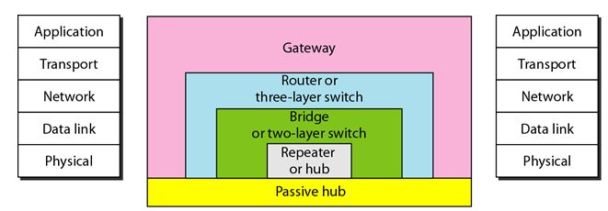

**Passive Hub**

* A passive hub is just a connector. It connects the wires coming from different branches.

**Repeater**

* A repeater is a device that operates only in the physical layer.
* A repeater receives a signal, regenerates the original bit pattern and sends the signal.
* A repeater can extend the physical length of a LAN.
* A repeater does not connect two LANs; it connects two segments of the same LAN.
* The repeater acts as a two port node. When its receives a frame from any of the port, it regenerates and forwards it to the other port

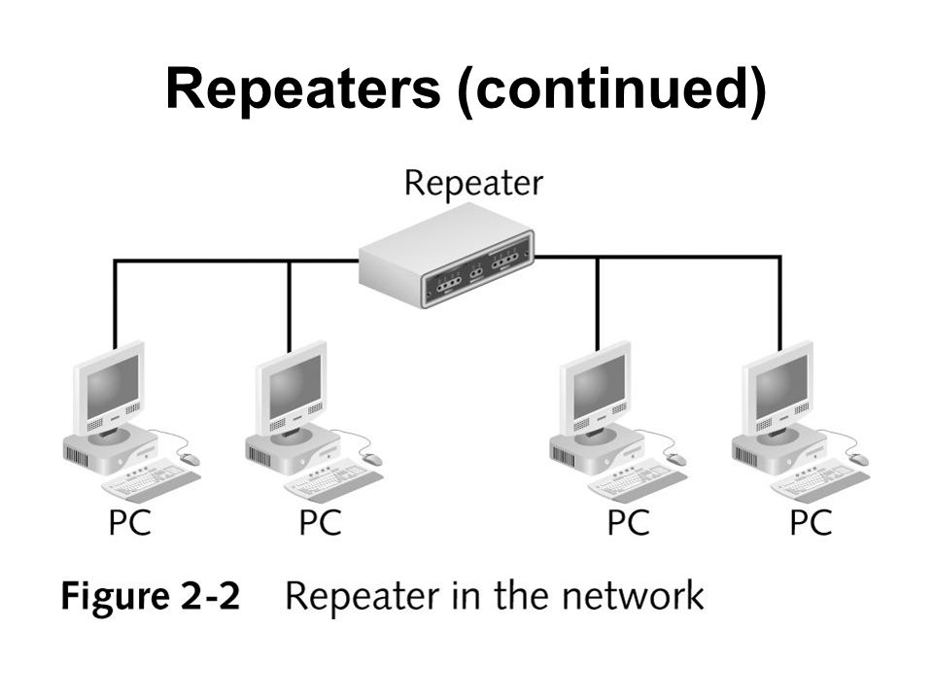

**Active Hub**

* Hub is a device that operates only in the physical layer.
* An active Hub is a multiport repeater.
* A Hub is a device that operates only in the physical layer.
* It is used to create a connection between stations in a star topology.

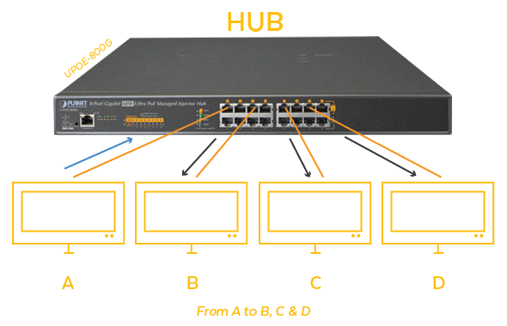

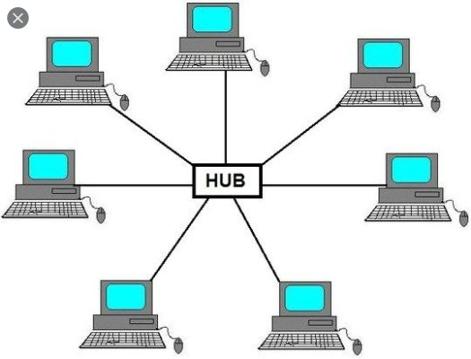

**Switch**

* A switch is a device that operates only in the data link layer.
* A switch connects devices within a network (LAN) and forwards [data packets](https://www.cloudflare.com/learning/network-layer/what-is-a-packet/) to and from those devices.

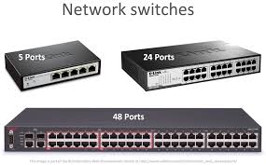

**Bridge**

* A bridge is a device that operates in the data link layer.
* A bridge is used to connect two or more communication networks (LANs) or network segments and creates a single network.
* It has a single input and single output port
* A Bridge has filtering capability. It can check the destination address of the frame and decide if the frame should be forwarded or dropped.

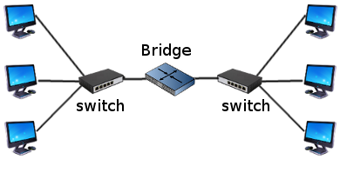

**Router**

* A Router is a device that operates in the Network layer.
* A router is a device that routes data packets based on their IP addresses.
* Routers normally connect LANs and WANs in the internet
* It has a routing table that is used for making decisions about the route
* Router is responsible for receiving, analyzing, and forwarding data packets among the connected computer networks.

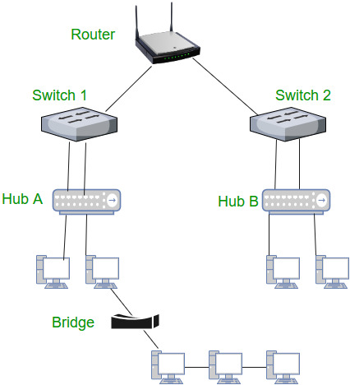

**Gateway**

* Gateway is a computerthat operates in all five layers of the internet
* A gateway takes an application message, reads it and interprets it.
* It can be used as a connecting device between two internetworks that use different models
* The gateway converts information or data from one protocol/format to another.

**NIC**

* A network interface Card (network adapter) is a [computer hardware](https://en.wikipedia.org/wiki/Computer_hardware) component that connects a [computer](https://en.wikipedia.org/wiki/Computer) to a [computer network](https://en.wikipedia.org/wiki/Computer_network).
* NIC is used to establish a wired or wireless connection over the network.
* NIC is used to convert data into a digital signal

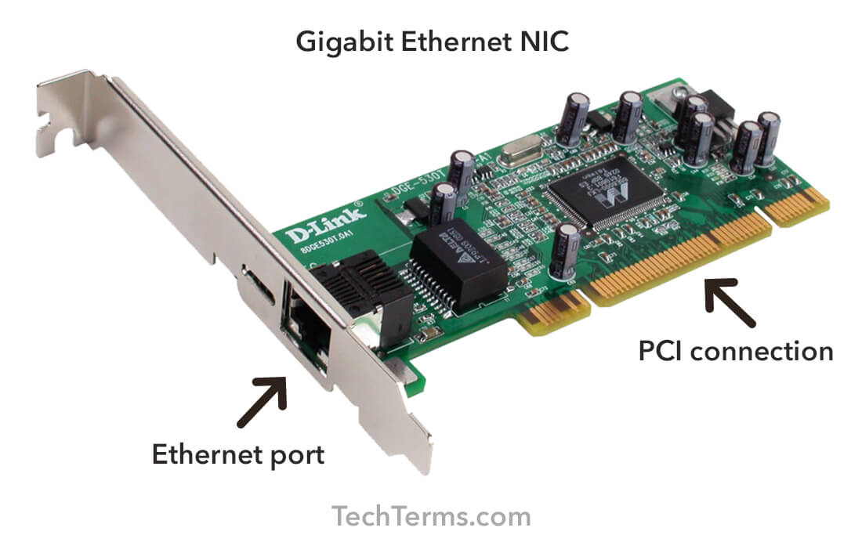

**Modem**

Modem is a device that enables a computer to send or receive data over telephone or cable lines. The data stored on the computer is digital whereas a telephone line or cable wire can transmit only analog data. The main function of the modem is to convert digital signal into analog and vice versa.

### Expt 4: Study different network cables and connectors. (Study Experiment)

* Coaxial Cable.
* Fiber Optic Cable.
* Shielded Twisted Pair (STP) Cable.
* Unshielded Twisted Pair (UTP) Cable.

**LAN Cables**

**Coaxial Cables**

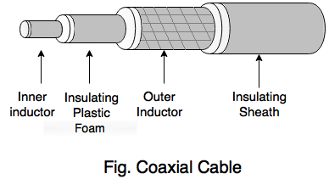

* A coaxial cable consists of two conductors (Copper wires) separated by insulation. The inner conductor transmits electric signals, and outer conductor acts as a ground.
* The entire assembly is wrapped in a sheath of Teflon or PVC.
* The advantage of coaxial cables is that they support high bandwidths and can transmit signals up to 10 kilometers.

The commonly used coaxial cables in Ethernet LANs are:

* **10base2:** Also known as Thinnetsupports a data transfer rate of 10 Mbps and can transmit signals without attenuation over a distance of 185 meters.
* **10base5:** Known as Thicknet,supports a data transfer rate of 10 Mbps over a distance of 500 meters.

**Twisted-Pair Cables**

* Twisted pair cables have two conductors that are generally made up of copper and each conductor has insulation.
* These two conductors are twisted together, thus giving the name twisted pair cables
* One of the conductors is used to carry the signal and the other is used as a ground reference only.
* The receiver uses the difference of signals between these two conductors.

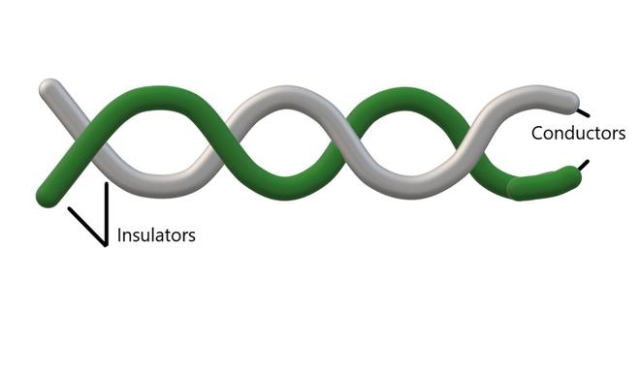

1. **Unshielded Twisted Pair Cables (UTP)**

* It is a pair of insulated copper wires twisted together to reduce noise generated by external interference.
* It is a wire with no additional shielding, like aluminum foil, to protect its data from the exterior.
* UTP is an unshielded twisted pair cable used in computer and telecommunications mediums.
* Its frequency range is suitable for transmitting both data and voice via a UTP cable. Therefore, it is widely used in the telephone, computers, etc.

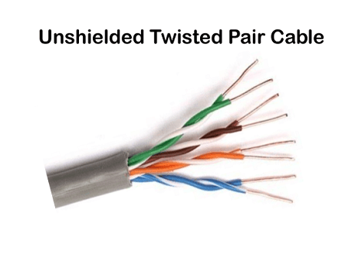

### Advantages of the UTP

1. Less expensive
2. It is designed to reduce crosstalk, RFI, and EMI.
3. Its size is small
4. The installation of the UTP is easier.
5. It is useful for short-distance.
6. It is suitable for transmitting both data and voice via UTP cable.

### Disadvantage of the UTP

1. It can only be used in length segment up to 100 meters.
2. It has limited bandwidth for transmitting the data.
3. It does not provide a secure connection for data transmitting over the network.

## STP (Shielded twisted pair)

* A shielded twisted pair is a cable with metal sheath or coating that surrounds each pair of the insulated conductor to protect the wire from external users and prevent electromagnetic noise from penetrating.
* It contains an extra wrapping foil or copper braid jacket to protect the cable from defects like cuts, losing bandwidth, noise, and signal to the interference.
* It is a cable that is usually used underground, and therefore it is costly than UTP.
* It supports the higher data transmission rates across the long distance.

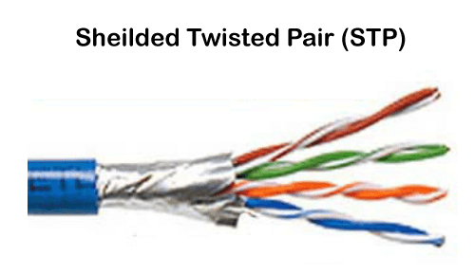

### Advantages of the STP cable

1. It has lower noise and attenuation than UTP.
2. Increases the data transmission rate.
3. It reduces the chances of crosstalk and protects from external interference.

### Disadvantages of the STP cable

1. It is the most expensive wire from UTP cables.
2. It requires more maintenance to reduce the loss of data signals.
3. It is used only as a grounded wire.

**Types of UTP Cables**

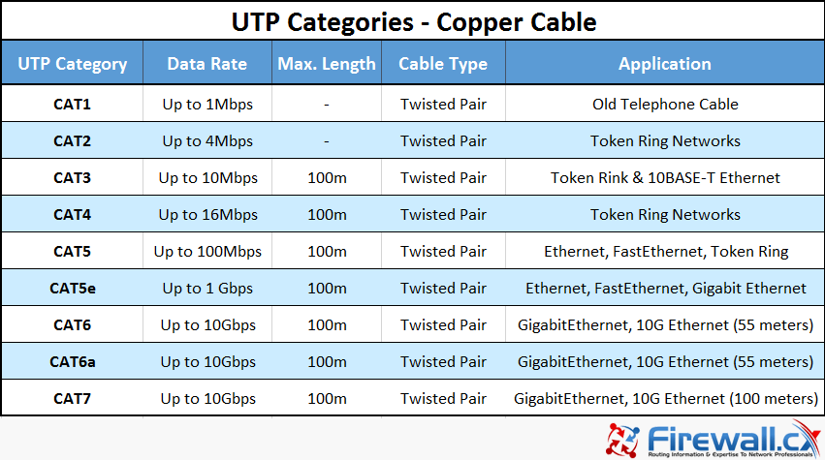

**Optical Fiber Cables**

* A fiber optic cable is made of glass or plastic and transmits signals in the form of light.
* The basic structure of an optical fiber consists of three parts; the core, the cladding, and the coating.
* Core: The core contains the optical fiber conductor (glass) that transmits light.
* Cladding: The core is surrounded by another optical material to prevent any light from escaping the core. The function of cladding is to reflect the light back into the core.
* Coating: Coating is simply a protective layer that is protecting core and cladding from the damage.



* At the source computer, the data to be transmitted is converted into light by a codec (coder and decoder).
* The codec converts the data into light, and the light is then transmitted across the cable with the help of either a Light Emitting Diode (LED) or an Injection Laser Diode (ILD).
* At the destination computer, a decoder receives the light beam and converts it into data.

**Connectors**

Connector is a device that terminates a segment of cabling or provides a point of entry for networking devices such as computers, hubs, and routers.

* Connectors for serial interfaces, such as RS-232 and V.35
* Ethernet connectors, such as RJ-45 and BNC connectors
* Fiber-optic cabling connectors, such as SC and ST connectors

|  |  |
| --- | --- |
| **V.35**  Used to connect high-speed routers to Channel Service Unit/Data Service Units (CSU/DSUs) for communication over leased lines such as T1 lines. | Shaxon CAB-SS-V35MT-B, Cisco Cable, V.35 Male to Smart Serial 26 Pin Male,  DTE Wiring, 10 Feet - Blue - Buy Shaxon CAB-SS-V35MT-B, Cisco Cable, V.35  Male to Smart Serial 26 Pin Male, |
| **RS-232 (Recommended Standard 232)**  Used for serial communication, it is used for connecting computer and its peripheral devices. used for connecting Data Transmission Equipment (DTE) and Data Communication Equipment (DCE) | What is RS232 DB9 serial port | RS232 pinout |
| Registered Jack 45 (RJ45) An 8-pin plug or jack is commonly used to connect computers onto Ethernet-based local area networks (LAN). | [https://ptgmedia.pearsoncmg.com/imprint_downloads/pearsonitcertification/images/articles/1211_fig5_lan-connectors.jpg](javascript:popUp('https://ptgmedia.pearsoncmg.com/imprint_downloads/pearsonitcertification/images/articles/1211_fig5_lan-connectors.jpg')) |
| **BNC** (**Bayonet Nut Coupling**) connector is a series of connectors used for connecting thinnet coaxial cabling to various networking components | Buy Fine Quality BNC Connectors for CCTV Camera- Set of 8Pcs Online at Low  Price in India | Unknown Camera Reviews &amp; Ratings - Amazon.in |
| Straight Tip (ST) used in fiber-optic cables | ST Connector Series - Senko Advanced Components |
| Subscriber Connector (SC) Used in data communication, CATV, and telephony environments. | SC Duplex Fiber Optic Connector price and specification SM MM |
| Lucent Connector (LC) Used in fiber-optic cables | LC Connectors: Everything you need to know |

**Firewall**

A firewall is a network security device that monitors incoming and outgoing network traffic and decides whether to allow or block specific traffic based on a defined set of security rules.

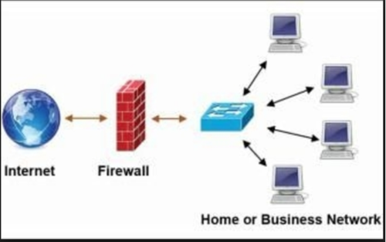

**Firm wares**

* Firmware is a software program or set of instructions programmed on a hardware device.
* It provides the necessary instructions for how the device communicates with the other computer hardware.
* Firmware is typically stored in the flash [ROM](https://techterms.com/definition/rom) of a hardware device.
* Firmware is used to control the functions of various hardware devices and systems
* Firmwares are embedded systems such as traffic lights, consumer appliances, digital watches, computers, computer peripherals, mobile phones, and digital cameras.

**ISP**

An Internet service provider (ISP) is a company that provides Internet connections and web access to both businesses and consumers.

ISPs may also provide other services such as email services, domain registration, web hosting, and browser services.

# Expt 5: Types of IPv6 Addresses -Study Experiment

IPv6 addresses are 128-bits. These longer addresses are partitioned into 16-bit bocks; then, each of these smaller blocks is turned into a 4-digit Hexadecimal number. Built into [IPv6](https://www.setra.com/blog/what-is-ipv6) addresses is notation identifying the application it will be used for. The first 64-bits of the address are for routing and the last 64-bits represent the interface or node.

An example of an IPv6 address is:

**3002:1ca7:45dc:0511:f3b4:0000:0000:1bac**

Different techniques can be used to shorten IPv6 addresses. The most common shortening method is to exclude repeating zeros. Two blocks of just zeros in a row can be noted with two colons instead. Also, any zeros starting a block can be left out of notation.

An example of a shortened IPv6 address is:

**3002:1ca7:45dc:511:f3b4::1bac**

## Address Types

* Unicast addresses are for individual devices
* Multicast addresses are for a group of devices on the same network
* Anycast addresses are for a group of devices in multiple locations sharing one destination IP address

## Special Addresses

There are also special addresses for IPv6. Global unicast addresses are the IPv6 equivalent of IPv4 public addresses; they are both unique and globally identifiable. Link-local addresses are used for IPv6 hosts communicating on a link. Unique-local addresses are globally unique but are designated for local communication only.

**Expt 6: Troubleshooting Common Network Issues and How to Resolve Them – Study Experiment**

Networks are networks. Despite best efforts to keep things smooth all the time every day, things happen. Here's a look at some common network issues, some tips for quickly resolving them, and even better, how to prevent them from occurring again.

**1. Duplicate IP Addresses**

When two devices attempt to share a single IP, you see the dreaded "Address Already in Use" Kill — with no ability to access the network.

**The Quick Fix:** The blame for this often rests with your router's default DHCP configuration. DHCP is probably trying to assign your new device an address at the [beginning of your subnet](https://www.cbtnuggets.com/blog/technology/networking/networking-basics-how-ip-and-mac-addresses-work), and another device may already occupy these low-numbered addresses with static IPs. If you've just introduced a new device or server to your network, it may have its own DHCP server. Simply disable the DHCP server on that device to restore sanity to your network.

**The Preventive Measure:** You can take one simple step to avoid IP conflicts by modifying your router's configuration to begin assigning DHCP addresses near the top end of your subnet, leaving the lower addresses available for devices that require static IPs.

**2. IP Address Exhaustion**

To troubleshoot this issue, use the ipconfig command. If the workstation has assigned itself an IP address that begins with 169.x.x.x, it means that no IP address was available from the DHCP server.

**The Quick Fix:** Some users on cable internet might not have a local router, in which case IP addresses are assigned on a limited basis directly from your ISP. You have probably run out of allowed IP addresses from your ISP. The solution to this is to purchase either a standalone router or WiFi access point with an integrated router. This creates your own local pool of internal addresses, ensuring you won't run out.

If you already have a local router with DHCP, the default address pool might be too small for your network. By accessing the DHCP settings on the router, you can adjust the size of the address pool to meet your network's needs.

**The Preventive Measure:** It's important that any internet-connected network have a local router in operation with NAT and DHCP, both for security reasons and to prevent IP address exhaustion. The router needs to be the only device connected to the modem, with all other devices connecting through the router.

**3. DNS Problems**

Errors such as The Network Path Cannot Be Found, IP Address Could Not Be Found, or DNS Name Does Not Exist, can usually be traced to a DNS configuration issue. The command line utility nslookup can be used to quickly show a workstation's DNS settings.

**The Quick Fix:** Workstations and other network devices can be configured to use their own DNS servers, ignoring the server assigned by DHCP. Checking the 'Internet Protocol Version 4 (TCP/IP)' settings for your adapter will show if an incorrect DNS server is specified, so just select "Obtain DNS server address automatically" instead.

**The Prevention Measure:** Your local router might be configured to operate as a DNS Server, creating a DNS pass-through to your ISPs servers. On busy networks, this may overload the capabilities of the router. Change your network's DHCP settings to directly access your DNS servers.

**4. Single Workstation Unable to Connect to the Network**

If only a single workstation is displaying the "No internet" message when opening a web browser, we can usually assume that the rest of the network is healthy and turn our attention to any hardware and software that is particular to this system.

**The Quick Fix:** To resolve this network issue, start by eliminating the obvious communication barriers such as a bad cable, [poor WiFi signal](https://www.cbtnuggets.com/blog/cbt-nuggets/optimize-your-home-network), failing network card or incorrect drivers. Ensure that the workstation's network adapter is configured with the correct IP, subnet, and DNS servers.

If that doesn't solve the problem, check any firewall software on the device to ensure that necessary ports are open to the external network. Common ports include 80 and 443 for web traffic, plus 25, 587, 465, 110, and 995 for email.

**The Preventive Measure:** It's usually best to leave all workstation TCP/IP settings to "Automatically assigned." Use a DHCP server to hand out a uniform configuration to all devices on the network. If a static IP is needed on a particular workstation or server, most DHCP servers allow the ability to create static IP mappings.

**5. Unable to Connect to Local File or Printer Shares**

Sharing problems are among the most difficult network problems to solve, due to the number of components that need to be configured properly.

Most commonly, [sharing problems](https://www.cbtnuggets.com/blog/cbt-nuggets/most-common-hardware-problems-solved) arise due to conflicts between mixed security environments. Even different versions of the same operating system sometimes use slightly different security models, which can make interconnection of workstations difficult.

**The Quick Fix:** We can cure sharing problems most efficiently by drilling down through the possibilities in this order:

1. Ensure that the required services are running. On Windows systems, the server, TCP/IP NetBIOS Helper, workstation, and computer browser services all need to be running. On Linux machines, Samba is the primary component required to share with Windows systems.
2. Check [your firewall(s)](https://www.cbtnuggets.com/blog/certifications/security/firewalls-of-middle-earth). It's very common for a workstation's firewall to be configured to block file and printer sharing traffic, especially if a new antivirus package is installed that introduces its own firewall. Firewall issues can also exist at the hardware level, so ensure that routers or managed switches are passing share traffic within the subnet. Speaking of subnet….
3. Ensure all workstations are on the same subnet. This problem typically only appears on complex networks, however, even simple networks sometimes have static-IP equipment with an improperly configured subnet. The result is that external traffic will move about just fine, while internal traffic will hit unexpected roadblocks.
4. All Windows network adapters will need File and Printer Sharing for Microsoft Networks, Client for Microsoft Networks, and NetBIOS over TCP/IP enabled.
5. Once the above checks have passed, it's finally time to check the most likely culprit, permissions. There are multiple layers of access required, each with their own interface within the OS. Check for:

* Systems configured with the wrong workgroup or domain.
* Incorrectly configured HomeGroup.
* Network type set to Public.
* Incorrect NTFS permissions.

**6. Local Network is Unable to Connect to the internet**

This situation can either be intermittent or persistent. Often times, the most difficult aspect of dealing with any external network problem is finding the company responsible. And then tasking them to solve the issue, particularly with [intermittent failures](https://www.cbtnuggets.com/blog/career/career-progression/the-diy-it-pro-a-guide-to-basic-troubleshooting) that are difficult to trace. It can sometimes be such a problem that organizations will have to switch internet providers in order to solve the issue.

**The Quick Fix:** A router and modem reboot is the first order of business. The tracert then utility can be used to identify communication breaks. It will clearly hiccup on the particular router hop that is causing the problem. Contact your ISP with your findings, providing screenshots as necessary.

**The Preventive Measure:** To avoid the finger-pointing that can prevent rapid resolution of external issues, do some research to ensure that you procure connectivity only from local Tier 1 providers. Other ISPs are more than happy to sell you service, however, they are simply piggybacking the Tier 1 connection, since they don't actually own the infrastructure in your area.

The goal is to remove as many middle-men as possible, so that when (not if) you experience a problem, one phone call is all that is required to identify the issue and get technicians to work on it.

**7. Slow Internet Performance**

Slow performance is typically due to congestion, or sometimes poor quality connections that have corroded or otherwise deteriorated. Congestion may not be directly related to bandwidth exhaustion, as a single overloaded port on a switch or router can diminish network performance.

This can be especially true on leased lines where dedicated bandwidth is to be expected, but speed tests indicate the network is not reaching its rated potential.

**The Quick Fix:** Use speed test websites, conducting tests from geographically remote servers. This can pinpoint areas of congestion on the ISP's network. In the case of cable internet, the local network is shared amongst your neighbors, committing your ISP to a costly bandwidth upgrade when saturation occurs. Report your findings to your ISP so that they can take steps to resolve the issue.

DNS servers are an often overlooked aspect of internet performance. Using incorrect DNS servers can result in routing congestion or load balancing problems. While you should typically use your ISP's DNS settings whenever possible, they may actually be routing traffic through overloaded web caches. You can temporarily adjust your DNS settings to use OpenDNS instead.

**The Preventive Measure:** if internet performance is critical, you'll need to procure adequate connectivity. While cable internet may be inexpensive, you could be setting yourself up for frequent jeers from employees. A local DSL operator may offer improved reliability for a slightly higher cost, but for the most consistent performance, you may find that an expensive leased line is a requirement for your organization.